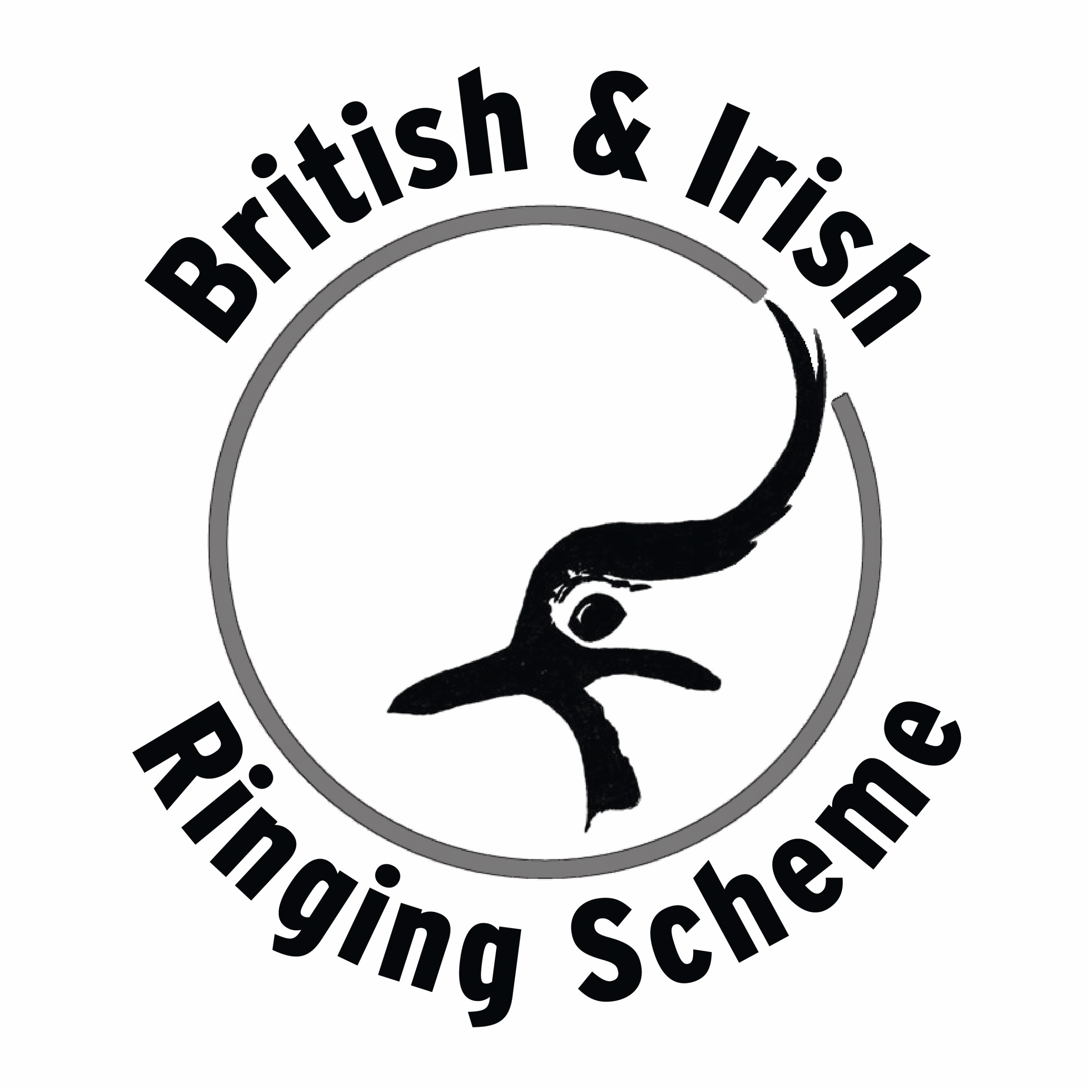
BIRD RINGING IN PROGRESS

PLEASE TAKE CARE

In this area, fine almost invisible nets are set up between poles to catch birds for ringing purposes. The nets are visited frequently and the birds are taken to our base a short distance away. There we record details of their rings, weights and measurements before releasing them.

PLEASE DO NOT TOUCH THE NETS OR ANY BIRDS THAT HAVE BEEN CAUGHT.
Trained ringers can easily remove the birds without harming them in any way. Inexperienced hands could well hurt the birds. Please do not stop beside the nets as your presence may scare the birds.

WHILE IN THE NETTING AREA PLEASE KEEP YOUR DOGS ON A LEAD AND PLEASE EXERCISE EXTREME CAUTION IF CYCLING OR ON HORSEBACK.
All the ringers involved in this study carry the appropriate permits issued by the British Trust for Ornithology on behalf of the government’s Nature Conservation Agencies. You are welcome to see these on request.

Name & contact details of ringer or group

