THE BRITISH TRUST FOR ORNITHOLOGY
86th Annual General Meeting

Notice is hereby given that the 83rd Annual General Meeting of the British Trust for Ornithology will be held on Saturday 29 November 2025 at 3pm, by videoconference.
The agenda and supporting papers will be available to view and download at www.bto.org/about-bto/governance-accounts. Paper copies may be obtained by telephoning 01842 750050 or emailing agm@bto.org.

By order of the Board
Simon Bradfield
Secretary

Agenda

1. Apologies for Absence
To receive.

3. Minutes
To approve the minutes of the 85th Annual General Meeting held on Saturday 30 November 2024.

4. Annual Report & Accounts
To receive the 91st Annual Report and Accounts of the Trust for the year ended 31 March 2025.

The Chair will introduce the Trustees’ Annual Report and the Hon Treasurer will introduce the Accounts.

5. Election of Trustees
Dr Lucy Wright and Mr Richard du Feu will retire with effect from 31 December 2025, creating two vacancies. Mr Iain Croucher’s 4 year-term is also due to end on the 31 December 2025. Board are grateful that Iain has offered to serve on Board for a further year. In addition, the Board proposes that Dr Geeta Ludhra, who was appointed as a co-optee Trustee on 1 January 2025 be formally elected as a full trustee.

- The Board proposes that Dr Rachel Thomas be elected to serve a four year term ending on 31 December 2029.

- The Board proposes that Dr Jamie Dunning be elected to serve a four year term ending on 31 December 2029.
- The Board proposes that Mr Iain Coucher be re-elected to serve a one year term ending on 31 December 2026.

- The Board proposes that Dr Geeta Ludhra be elected to serve a three year term ending on 31 December 2028.
6. Appointment of Auditors
The Board proposes that Ensors Chartered Accountants be re-appointed as auditors of the Trust.

7. Any Other Business

Nominee Biography
Dr Rachel Thomas

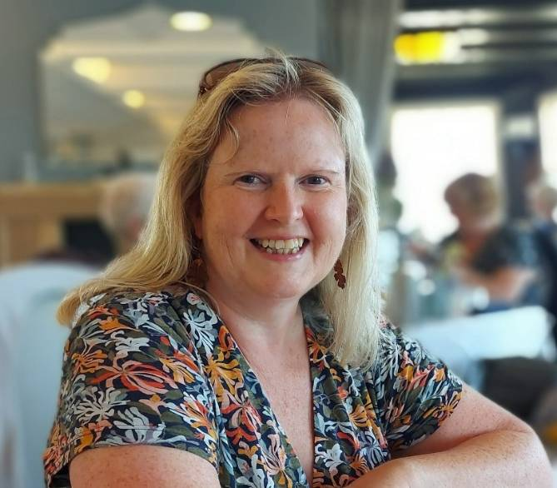
Rachel is a Consultant Clinical Psychologist and Adult Psychotherapist by background with more than 30 years of clinical and management experience. She has worked in many and varied senior leadership roles within the healthcare sector since the early 1990s, both in the NHS and for NGOs. She has been a Director of Services, a Company Director and a CEO. Most recently, she founded and is Director of her own company undertaking complex mental health assessments for the UK Tribunals Service. Her background in social science has led to her involvement in both small and large-scale research projects including a doctoral dissertation using qualitative methodology and as the Research Clinician for a reputable NHS Randomised Control Trial.

Rachel has been a nature lover, particularly in relation to birds, and a keen conservationist from a young age and has undertaken both practical and public facing conservation work as a volunteer over many years for organisations such as the RSPB, TCV and WWT. She has a close connection with Norfolk and is a frequent visitor with a particular interest in wading and coastal birds.

Dr Jamie Dunning
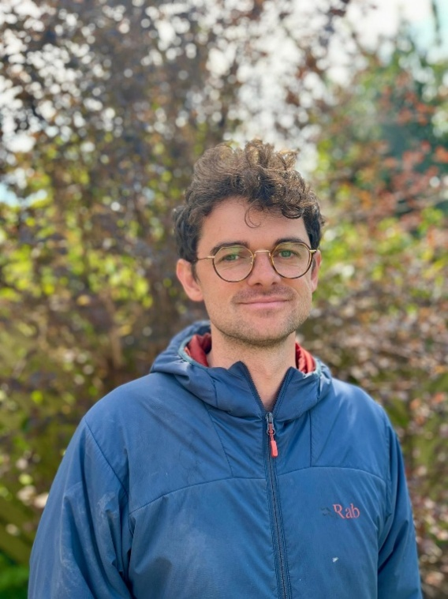
Jamie is an ornithologist spanning academic research and commercial application of bird survey and ringing data. He completed his PhD at Imperial College London on the evolution of social behaviour in birds, using the long-term genetic population of House Sparrows on Lundy Island. Since then, he has worked across diverse interests, from behavioural ecology and visual signal evolution to the spread of zoonotic disease through wild bird communities.

Outside academia, Jamie co-developed recent bird survey guidance for commercial application and sits on the group overseeing their continued development. He runs Skopeo, a spin-out business consulting on technical ornithology, survey design and resourcing. Jamie is also a ringing trainer with a new group in central Bristol, covering Severnside and the important River Severn SPA. Much of his ringing has focused on long-term and single-species studies, and their value to research and conservation.

Jamie is a life-long birder and BTO supporter. He looks forward to bringing his experience bridging academic research and commercial practice to the BTO board, exploring how BTO data and volunteer effort can be applied in both sectors.

Mr Iain Coucher
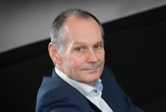
Iain is an experienced Chief Executive who has led a number of large organisations involved in the delivery of public services in technology, infrastructure, transport and defence sectors. He is a life-long birder and is passionate about the environment and sustainability. He owns a small, coastal farm in west Scotland that he manages for the benefit of birds and other wildlife.
He has been a trustee of a global environmental charity, Earthwatch (Europe) for around six years. He is committed to continual learning and, over the last decade has completed Masters degrees in Environmental Decision Making and in Systems Thinking (with a focus on climate change and ocean acidification). He was awarded an honorary doctorate from Cranfield University, in 2019.
Dr Geeta Luhdra
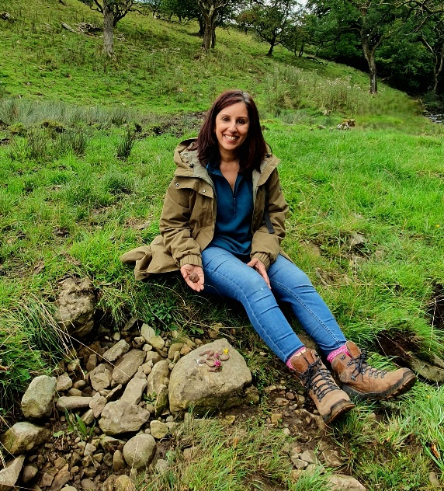
Dr Geeta Ludhra is a Senior Lecturer in Education and Associate Dean for Equity at Brunel University. She has a strong background in school leadership and equity-social justice roles across schools and community projects. Geeta has served as a co-opted Trustee since
Alongside her academic role, Geeta leads a non-profit, registered social enterprise called Dadima’s CIC, set up to encourage people from Black Asian and Minority Ethnic communities (those groups who are statistically under-represented in UK natural landscapes) to engage in and enjoy the benefits of National Parks, National Landscapes, the Chilterns countryside. She also works with rural museums on community-led initiatives to create events and collections that are more inclusive. Dadima’s CIC is a family-run walking group that has a programme of monthly nature-themed events and promotes intergenerational connections through walking and talking, biodiversity research discussions, sharing heritage stories and celebrating diverse forms of nature knowledge.
Geeta’s interest in grass-roots activist work is inspired by her interest in making a difference through community-led projects that connect people from diverse backgrounds in creative ways. Geeta has a keen interest in mental health and well-being across the generations, and exploring ways in which nature connectedness can support this.

