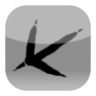
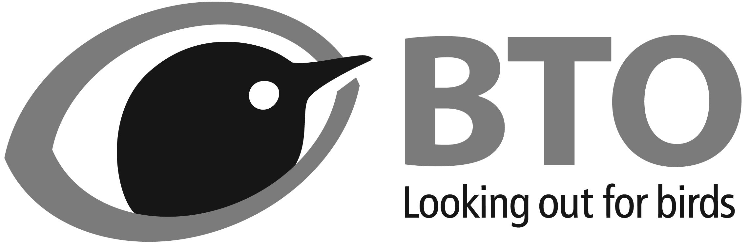
Thetford Nunnery Lakes BTO reserve (TL8781)
Bird list – non-breeding season (September–February)
BirdTrack
Occurrence key:
VC = very common; recorded on almost all visits
C = common; recorded on most visits
FC = fairly common; recorded on 25–50% of visits
S = scarce; recorded on <25% of visits
R = rare; recorded on <5% of visits
Date: _______ / _______ / _____________ Start time: ______:______ End time: ______:______
SPECIES | Present | Count | SPECIES | Present | Count
Mute Swan (C) |  |  | Kingfisher (FC)
Greylag Goose (VC) |  |  | Green Woodpecker (C)
Canada Goose (VC) |  |  | Great Spotted Woodpecker (FC)
Barnacle Goose (S) |  |  | Magpie (VC)
Egyptian Goose (C) |  |  | Jay (VC)
Shelduck (R) |  |  | Jackdaw (VC)
Mandarin Duck (R) |  |  | Rook (C)
Wigeon (S) |  |  | Carrion Crow (VC)
Gadwall (FC) |  |  | Goldcrest (C)
Teal (C) |  |  | Blue Tit (VC)
Mallard (VC) |  |  | Great Tit (VC)
Shoveler (S) |  |  | Coal Tit (VC)
Pochard (S) |  |  | Marsh Tit (C)
Tufted Duck (VC) |  |  | Skylark (S)
Goldeneye (R) |  |  | Long-tailed Tit (VC)
Goosander (S Sep–Nov; FC Dec–Feb) |  |  | Chiffchaff (S)
Red-legged Partridge (VC) |  |  | Blackcap (S Sep–Oct; R Nov–Feb)
Pheasant (VC) |  |  | Nuthatch (S)
Cormorant (C) |  |  | Treecreeper (FC)
Bittern (R) |  |  | Wren (VC)
Little Egret (FC) |  |  | Starling (C)
Grey Heron (C) |  |  | Blackbird (VC)
Little Grebe (S) |  |  | Fieldfare (FC)
Great Crested Grebe (S) |  |  | Song Thrush (C)
Sparrowhawk (FC) |  |  | Redwing (FC)
Buzzard (FC) |  |  | Mistle Thrush (S)
Kestrel (FC) |  |  | Robin (VC)
Peregrine (R) |  |  | Dunnock (C)
Water Rail (FC) |  |  | House Sparrow (FC)
Moorhen (VC) |  |  | Grey Wagtail (S)
Coot (VC) |  |  | Pied Wagtail (FC)
Lapwing (S) |  |  | Meadow Pipit (S)
Curlew (S) |  |  | Chaffinch (VC)
Woodcock (S) |  |  | Brambling (FC)
Snipe (FC) |  |  | Greenfinch (VC)
Black-headed Gull (VC) |  |  | Goldfinch (VC)
Common Gull (C) |  |  | Siskin (C)
Lesser Black-backed Gull (VC) |  |  | Linnet (S)
Herring Gull (S) |  |  | Lesser Redpoll (FC)
Yellow-legged Gull (R) |  |  | Common Crossbill (R)
Great Black-backed Gull (S) |  |  | Bullfinch (FC)
Feral Pigeon (S) |  |  | Yellowhammer (S)
Stock Dove (S) |  |  | Reed Bunting (FC)
Woodpigeon (VC)
Collared Dove (VC)
Barn Owl (S)
Little Owl (R)
Tawny Owl (S)
Please submit your records at www.birdtrack.net and report any unlisted or rare (R) species to BTO Reception.

